**IriEnvoy-MK**

**Software Developer’s Manual**

Version 1.1, April 2023





**Document Change Record**

This page records any updates and revisions made to the IriEnvoy-MK Software Developer’s Manual.

|  |  |  |  |
| --- | --- | --- | --- |
| Doc ver. | Date | Change Description | SDK ver. |
| 1.0 | 2023.03.27 | Initial release of SDK & document. | 2.32.25 |
| 1.1 | 2023.04.25 | Revised SDK, software package. | 2.32.26 |
|  |  |  |  |
|  |  |  |  |
|  |  |  |  |
|  |  |  |  |
|  |  |  |  |
|  |  |  |  |
|  |  |  |  |
|  |  |  |  |

**Notice**

The information contained herein is provided solely for the purpose of assisting customers to understand how to operate and integrate IriTech’s hardware and software and is not to be released, reproduced, or used for any other purpose without written permission of IriTech, Inc.

IriTech reserves the right to make changes on this hardware and software with the intent to improve its functionalities. Information and specifications contained in this document are subject to change without prior notice and do not represent a commitment on part of IriTech.

© 2023 IriTech, Inc. All rights reserved.

**Table of Contents**

1. Introduction 4

1.1. Manual Overview 4

1.2. IriEnvoy-MK Overview 4

1.2.1. IriEnvoy-MK Models 4

1.2.2. Device Features 4

1.2.3. Onboard Iris Image Acquisition 4

1.2.4. On-board Iris Image Quality Assessment 5

1.2.5. Power Management 5

1.2.6. Supported development platform 6

1.2.7. Host with no OS or unsupported OS 6

1.2.8. Special note for Android platforms 6

1.2.9. Endianness 6

1.3. Terms and Abbreviations 6

2. Software Installation 8

2.1. IriEnvoy-MK SDK Installation 8

2.1.1. C/C++ 8

2.3. Device Driver Installation 10

2.3.1. MS Windows 10 11

2.3.2. Linux 11

2.3.3. Android 11

3. Software Specification 11

3.1. Library Description 11

3.1.1. C/C++ 11

3.2. Standard Capturing Procedure 11

3.2.1. Operation Modes 11

3.2.2. Capturing Modes 12

3.2.3. Standard Capturing Procedure 12

3.3. Supported Image Types 12

3.4. Supported Image Formats 13

3.4.1. IriTech Standard Image Format 13

3.4.2. Raw Image Format 13

3.4.3. JPEG2000 Image 13

3.4.4. Iris ISO Standard Image Format 13

4. Demonstration Code and Utilities 14

4.1. Demonstration with non-cryptographic functions 14

4.1.1. Device Info 14

4.1.2. Library Info 14

4.1.3. Error Code 15

This sample helps users to quickly get the detailed information of all errors of device. 15

4.1.4. Capturing Process 16

5. Software Warnings and Precautions 16

5.1. Red-Eye Effect Cautions 16

5.2. Device IO Failure Cautions 17

5.2.1. Hardware 17

5.2.2. Software 17

6. Troubleshooting and FAQ 18

7. Legal Notice 21

7.1. Warranty Agreement 21

7.2. End-User License Agreement 25

# Introduction

## Manual Overview

The purpose of this manual is to provide useful information on IriTech’s family of embedded camera systems. It includes an overview of the software development kit, its functionality, component terminology, and useful tips on how to begin programming your own application. For details of application programming interfaces, please see the corresponding API Reference Manual. Information about hardware specifications can be found in the Hardware Developer’s Manuals for a specific device.

## IriEnvoy-MK Overview

IriEnvoy-MK is an iris biometrics device that has its own computation power, memory, storage, and peripherals to perform iris image acquisition.

### IriEnvoy-MK Models

IriEnvoy-MK device supports USB connection where both data communication and power supply are done via a single USB cable. It is supposed to work with a host PC with any OS.

Noticeably, IriEnvoy-MK employs IriTech’s top-performing iris image quality assessment and iris recognition algorithms, which were proven in extensive NIST’s IREX tests.

### Device Features

Every IriEnvoy-MK device has embedded automated iris.

### Onboard Iris Image Acquisition

The IriEnvoy-MK device contains a compact iris camera that consists of one (monocular device) or two image sensors (binocular device) for image acquisition. During operation, an independent infrared LED flexibly illuminates the details inside the iris. Images from the sensors are streamed through a Quality Measurement module (QM) inside the device for real-time evaluation to filter out non-eye or unqualified eye images. Many quality factors are taken into account in QM to make sure that the selected qualified images contain detailed iris textures with sufficient sharpness. This quality analyzing mechanism is so effective and fast that the best qualified iris image is detected and captured immediately right after a person’s eye enters the focus range of the camera. The whole process above is called the capturing process, and can be customized with different operation modes, capturing modes, and quality alternatives.

Every IriEnvoy-MK device supports an automated capturing process in which the device controls its peripherals to get images, evaluate every image, and make every qualifying decision by itself without any external support. Users, however, should know how to operate the device to make this automation produce desirable quality images.

Capturing process in IriEnvoy-MK can be customized as a callback function which is invoked only when there is a new frame or new capturing status or errors so that developers can easily handle what to do next.

### On-board Iris Image Quality Assessment

IriEnvoy-MK is equipped with IriTech’s winning iris image quality assessment algorithms (NIST IREX II) to aggressively evaluate the captured image at the end of each capture to produce its total quality score and occlusion information. These quality metrics make it easier for developers to set different quality standards for enrollment and matching.



### Power Management

**NOTE**: Device power control feature is not supported yet by IriEnvoy-MK device.

|  |  |  |  |
| --- | --- | --- | --- |
| **Power modes** | **Description** | **Wakeup by** | **Cautions** |
| DPO_REBOOT | Reboot device's operating system. Device connection will be dropped. It takes several seconds (about 5s) to have the rebooting device ready. Function IIC_CloseDevice() should be called to close the current device handle. To use device again, user should scan and open it again to get new device path and handle. | Any activity on USB/UART communication link (except for KEEP ALIVE frames from USB). |  |
| DPO_SLEEP | Device connection will be dropped.Device's feature will not be accessible until it's is waked up. It takes several seconds (about 2s) to have complete this operation. User should use API IIC_ControlPower() with option DPO_WAKEUP to the same device handle to wake up device and make it functions accessible. | Re-enumeration on USB port | Device needs some amount of time (several hundred miliseconds) to put itself into SLEEP. During this time, it puts its peripherals including USB and itself into low power state. If there is an incomming command during its sleeping procedure, communication is corrupted and host may receive unexpected data or error. |
| DPO_WAKEUP | Device wakeup after it has been put in standby mode. This operation must be done on the same device handle that was called  with option DPO_SLEEP |  |  |



### Supported development platform

IriEnvoy-MK currently supports USB drivers and development libraries for the following operating systems.

* Windows XP and Windows 7,10,11 32-bit/64-bit
* Linux Ubuntu 32-bit/64-bit
* Some Embedded Linux
* Android

### Host with no OS or unsupported OS

It is easy to integrate IriEnvoy-MK into existing biometric systems although they may not have an operating system or have operating systems not listed in 1.2.6. Developers should contact IriTech, Inc. to obtain IriEnvoy-MK Packet Protocol Manual, which details the ways in how to send/receive commands and data to/from IriEnvoy-MK and how to process exchanged data at communication level.

### Special note for Android platforms

IriTech provides two development alternatives for Android platform:

* Android on native code: Driver and SDK are built on native code (written in C/C++). To install driver, developer needs to have *root* privilege of the Android host target. Native SDK easily interacts with managed code (written in Java) by Java Native Interface (JNI). Device manufacturer can use these native driver and SDK to enable IriEnvoy-MK directly in the host firmware. It can be built on almost all kernel and Android versions. Developers need to contact with IriTech, Inc. to provide their kernel version, configuration and tool-chain to get the compatible driver and SDK.
* Android USB Host Mode: Driver and SDK are developed on managed code (written in Java) based on Android USB Host APIs in android.hardware.usb. They are easily installed and require no root privilege. However, the Android-powered device has to enable USB host mode and Android version has to be 3.1 and higher. This alternative is good for commercial Android devices on which consumers have no detail knowledge about the kernel and root privilege.

### Endianness

Byte order of host system significantly affects the communication with the IriEnvoy-MK device. The SDK library currently supports system with little endian byte order only. We are testing and going to support big endian byte order soon.

## Terms and Abbreviations

This section lists and defines terms and abbreviations used throughout this document.

|  |  |
| --- | --- |
| **Advanced Encryption Standard** | A symmetric encryption standard adopted by the U.S. government. It is a block cipher design that works on a block size of 128 bits and a key size of 128, 192, or 256 bits. |
| **AES** | See Advanced Encryption Standard. |
| **Binary Large Object** | A collection of binary data. |
| **BLOB** | See Binary Large Object. In this document context, BLOBs are used to store data structures that are serialized into a sequence of bytes. |
| **Block** | In symmetric cryptography, block is a fixed-length group of bits. |
| **Block cipher** | A symmetric key cipher operating on fixed-length blocks. A block cipher algorithm encrypts a block of plaintext into a block of cipher text of the same size. |
| **Byte** | A data element that is eight bits in size. |
| **CA** | See Certificate Authority. |
| **Capturing process** | A process occurs inside device to capture qualified iris images. |
| **CBC** | See Cipher-Block Chaining. |
| **Certificate Authority** | A trusted third party in PKI that issues digital certificates for use by other parties. |
| **Cipher-Block Chaining** | A block cipher mode of operation. The message is divided into blocks of fixed-length. Each block of plaintext is XORed with the previous cipher text block before being encrypted. The first block is XORed with a random Initialization Vector. |
| **DER** | See Distinguished Encoding Rules. |
| **Distinguished Encoding Rules** | A standard message transfer syntax. It is intended for situations when a unique encoding is needed, such as in [cryptography](http://en.wikipedia.org/wiki/Cryptography" \o "Cryptography), and ensures that a data structure produces a unique serialized representation. |
| **Enumeration** | A procedure to detect and identify an IriEnvoy-MK device. |
| **Host** | The computer system where an IriEnvoy-MK is installed. This includes the hardware platform (CPU, bus, etc.), operating system and SDK 2000 in use. |
| **Initialization Vector** | A block that is required to allow a block cipher to be executed in several modes of operation, such as CBC. It must be known by the recipient of the encrypted data to be able to decrypt that data. Its size depends on each encryption algorithm, e.g., 128 bits in AES. |
| **Iris camera** | A camera specially designed to capture iris images. It has infrared LEDs to provide illumination to highlight the texture inside irises.  Each IriEnvoy-MK device consists of one (monocular device) or two image sensors (binocular device). |
| **Iris Recognition module** | A software component in device that is in charge of generating templates from iris images and matching templates. It also manages a template gallery. |
| **Library** | A collection of data structures, types, subroutines and resources that are provided IriEnvoy-MK SDK. |
| **Quality Measurement module** | A software component in device that is in charge of evaluating images stream from iris camera to select the best qualified iris images. |

# Software Installation

The following software packages must be installed properly to permit interfacing between the hardware and the host.

**IriEnvoy-MK Device Driver Package:** Depending on the host Operating System, there may be need of additional IriEnvoy-MK device driver so that the host system can recognize the device and setup data communication with it.

* IriEnvoy-MKSDK **for Developers:** This package contains necessary developing resources including the library and demonstration codes to help developers program and control IriEnvoy-MK device in their customized applications.

## IriEnvoy-MK SDK Installation

* *Note: The SDK version and name in the example screenshots may differ from the users’. The SDK version is also subject to change without notice.*

### C/C++

1. Download or copy the software package for C++ SDK. Double click on the “setup.exe” file.

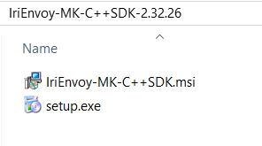

The installer will guide you through all the installation process. Select the appropriate options and click “**Next**” to move to the next steps.

1. If you want to install the SDK in a different folder instead of the one set as default, click “**Browse**” and specify the desired folder. If not, click “**Next**” to continue.

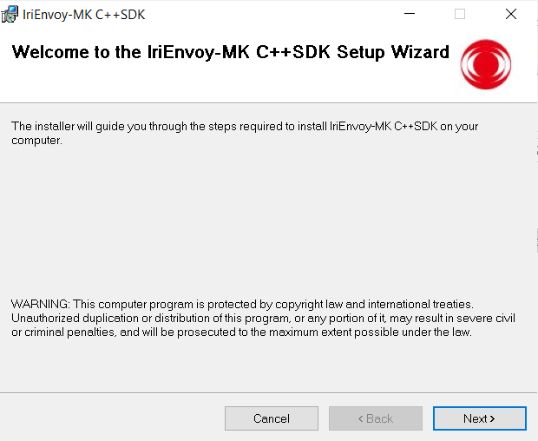

1. Follow the instructions from the installer to finish the setup process. When the following wizard appears, click “**Close**” to successfully complete the SDK installation.

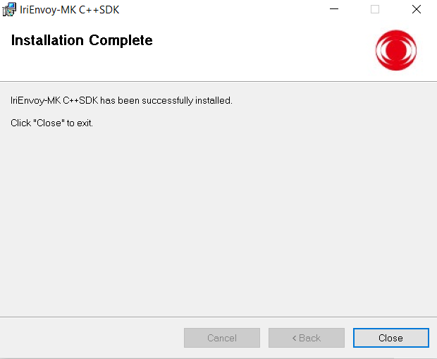

When finished, you can verify if the program has been properly installed by checking the installation folder.

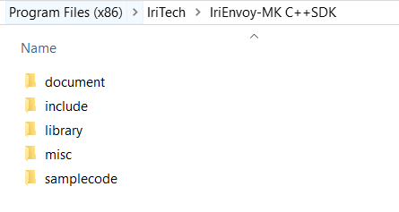

## Device Driver Installation

Most OS platform can recognize IriEnvoy-MK device. Driver installation guide will be provided only for systems that need further driver setup.

### MS Windows 10

### Linux

### Android

# Software Specification

## Library Description

IriEnvoy-MK SDK provides libraries of ready-to-use APIs to be easily called through applications programmed in C/C++.

Developers can use this library to easily control and customize the functionalities of IriTech’s device, such as device management, capturing process.

### C/C++

The library includes the following components:

* Three header files:
  + IICAPI.h
  + IrisDef.h
  + IndicatingLED .h
  + DeviceAttribute.h
  + CapturingEventCallback.h
  + BaseError.h
* Import library file:
  + For Windows win32 platform: libIriEnvoyMK32.lib
  + For Windows x64 platform: libIriEnvoyMK64.lib
* Dynamic library file: libIriEnvoyMK.dll
  + For Windows win32 platform: libIriEnvoyMK32.dll
  + For Windows x64 platform: libIriEnvoyMK64.dll
  + For Linux Ubuntu 32 bit platform: libIriEnvoyMK32.so
  + For Linux Ubuntu 64 bit platform: libIriEnvoyMK64.so

## Standard Capturing Procedure

IriEnvoy-MK SDK offers different operation modes, capturing modes to help developers balance ease of the capturing procedure against high iris image quality.

### Operation Modes

* **Auto Capture Mode:** As soon as the capturing process is activated, every image from the camera is automatically streamed through a Quality Measurement module (QM) for real-time evaluation, to be classified as good or bad, and to have the best image selected at the end. All activities in this operation mode are automated by the device without the outside support.

### Capturing Modes

* **Frame-Based Search Mode:** In the Frame-Based Search Mode, the developer specifies the number of qualified images that must be captured before the capturing process ends. An image is considered qualified when it passes the basic level of qualities from the QM module. Once the desired number of qualified images is reached, the best image will be selected and checked against the Minimum Quality Tolerance condition. If satisfied, it will be returned as the captured image. Otherwise, no image is returned and user must initiate the capturing process again.
* **Timed-Based Search Mode:** In the Timed-Based Search Mode, once the first eye image is detected, the device will continuously capture frames across a pre-defined period of time. When the period elapses, the best image will be selected among the captured frames and checked against the Minimum Quality Tolerance. If satisfied, the image will be returned as the captured image. Otherwise, no image is returned and user must initiate the capturing process again.

### Standard Capturing Procedure

The IriEnvoy-MK device is equipped with an iris camera that captures one iris image at a time. A standard capturing process will lead to the following stages:

* **Ready:** In this stage, the capturing process is initiated. The infrared LED is turned on to lighten the texture inside the irises. The subject should place his/her eye at about 5 cm (2 inches) away from the front of the camera in perpendicular direction and follow the capturing procedure mentioned in the Basic User’s Guide, so that the camera sensor can detect the eye. In Auto Capture Mode, images from iris camera start streaming through Quality Measurement module for live evaluation. For detailed information on capturing distance range, please refer to the Hardware Specification document.
* **Capture:** Whenever the first eye image is detected, capturing process will change to the capturing stage. In this stage, the subject must continue to move slowly towards the camera if fixed-focused devices are used or stand still and allow camera lenses to move on their own if auto-focused devices are used.
* **Complete:** When the conditions for completing the capturing process have been met (i.e., a reasonable duration of time or a reasonable number of qualified eye images detected), the capturing process stops and enters the timeout/finish stage. The infrared LED will turn off.
* **FailedToCapture**: The capturing process entered **Complete** stage but then failed in selecting out the best qualified iris image. This is a special state which may relate to internal errors.
* **Abort:** If something abnormal happens (e.g., no images from iris camera or capturing process is cancelled), it will cause the capturing process to terminate before finishing its normal routine and this stage will be entered. The infrared LED will turn off. The user should start the procedure over again.

More details on how to carry out the capturing procedure properly and on how to improve the quality of captured images can be found in the Basic User’s Guide.

Every iris image satisfying the quality standards from the live QM module will be qualified for iris recognition. However, to enhance matching accuracy, not all of qualified images are selected. Only the image with the best quality is selected and used as the output image of that capturing process.

## Supported Image Types

* Captured image with original size (K1)
* VGA image (K2)
* Cropped image (K3)
* Cropped and Masked Image (K7)

Please refer to the specification of ISO/IEC 19794-6:2011 for more detailed information.

## Supported Image Formats

### IriTech Standard Image Format

IriTech has its own Standard Image Format and only manipulates on the type called the IriTech image. This standard format encapsulates images captured from IriTech’s devices. Besides the raw image data, it contains the header information and an image data signature, which differentiates the IriTech image from any other data format.

By employing its own IriTech image, IriEnvoy-MK device can operate more reliably and precisely. Before carrying out any functions on the image, the image sections are examined to verify whether any part is corrupted or not. If any, the image will be rejected. Moreover, the device will not accept any other image formats except the IriTech image. This IriTech image cannot be processed anywhere else except in an IriTech device. This ensures the operations of the IriEnvoy-MK devices to be secure and safe.

IriTech image can be used compatibly among IriTech’s products.

### Raw Image Format

IriEnvoy-MK devices output raw image directly and also allow users to covert an IriTech image into a raw image format (size 640x480). This raw format simply contains the plain image data with no other information. It allows users themselves to manipulate on the captured image data as desired.

### JPEG2000 Image

Image can be outputted in JPEG2000 format with compression quality from 1 to 100.

### Iris ISO Standard Image Format

In the year of 2005, the International Standards Organization (ISO) defined the iris standard format ISO/IEC 19794-6 to facilitate data exchange among biometric authentication systems that implement iris recognition. IriEnvoy-MK is capable of producing images in this standard format, allowing easy integration with other biometric systems.

ISO/IEC 19794-6 specifies image compression including JPEG and JPEG2000. IriEnvoy-MK offers two options in gray scale format: raw image and compressed JPEG2000 image.

Recently, ISO announced the iris standard format ISO/IEC 19794-6 version 2011 with some modifications from the old version 2005. The most important modification made was to support a variety of Image Kinds as follows: K1, K2, K3, and K7.

|  |  |
| --- | --- |
| Image Kind | Definition |
| K1 | Iris image of any size |
| K2 | Iris image of size VGA 640x480 pixels |
| K3 | Iris image where non-iris parts are cropped |
| K7 | Iris image where non-iris parts are cropped and masked |

With the introduction of K3 and K7, customers are offered with more options to store just the useful parts of iris images in which it also leads to improving storage ability as well as lowering overhead transmission images through communication channels.

# Demonstration Code and Utilities

The following step-by-step tutorials and the corresponding demonstration code show you how to use IriEnvoy-MK SDK in a basic manner. We will purposely cover all the major abilities of the SDK to provide the best support for customers. The demonstration code was written in C++, and packaged as a full solution on each platform. Users can compile, execute or parse each part of the code for easy investigation.

Before running these demonstrations, please make sure the appropriate driver is loaded, the device is connected to the host system, and the host is able to recognize the device correctly.

## Demonstration with non-cryptographic functions

**For Windows 10 platform**

* Go to C:\Program Files (x86)\IriTech\IriEnvoy-MK C++SDK\samplecode \samples.sln to open the C++ demonstration solution.

**For Android platform**, it is strongly recommended for the developers to refer to Java demonstration code on Windows or Linux to attain the adequate instruction.

***Note****: The SDK version is subject to change without notice.*

### Device Info

This sample helps users to quickly get the detailed information of the current device.

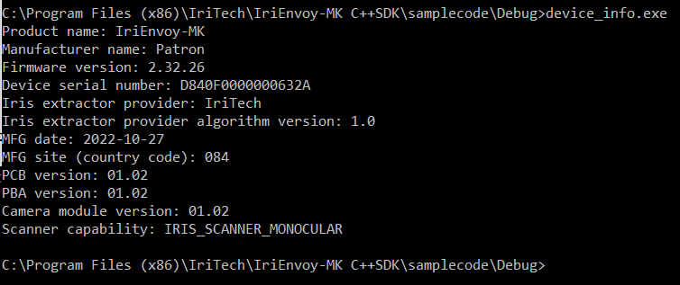

### Library Info

This sample helps users to quickly get the detailed information of the library.

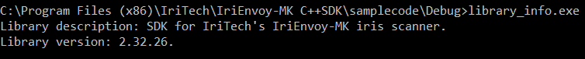

### Error Code

### This sample helps users to quickly get the detailed information of all errors of device.

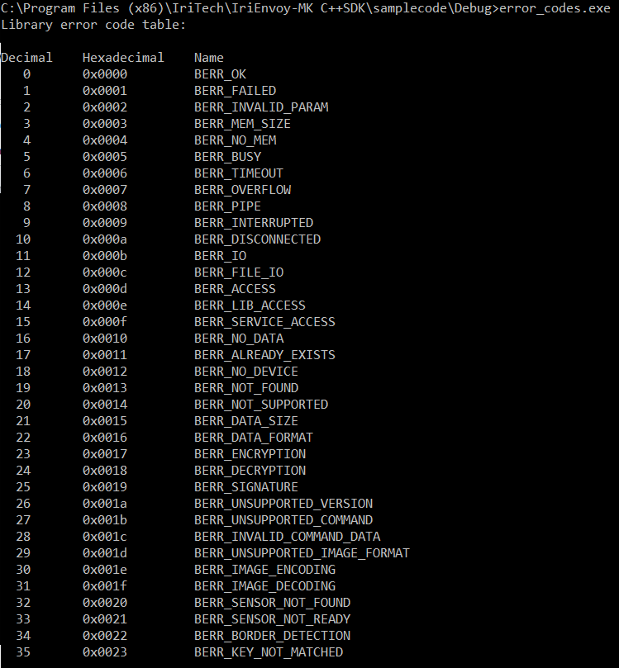

### Capturing Process

The codes demonstrate how developers can easily see their own capturing process. They can query the image quality including total score and usable area at the end of each capture session as well.

Two ways to control the capture process:

1. Capture with implementation using callback
2. Capture with implementation not using callback

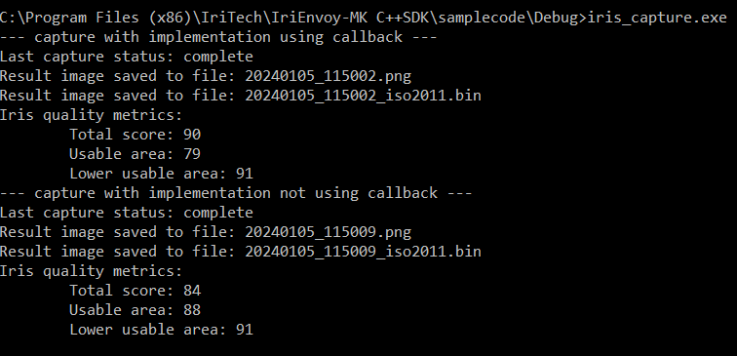

Capturing process demonstrates the usages of:

* **IIC_ScanDevice**
* **IIC_OpenDevice**
* **IIC_StartCapturing**
* **IIC_GetCapturingStatus**
* **IIC_GetResultImage**
* **IIC_GetResultImageQuality**
* **IIC_CloseDevice**

# Software Warnings and Precautions

IriEnvoy-MK has been tested successfully with robustness, reliability, speed, and high accuracy. However, any intentional or unintentional wrong usages of the device and the SDK will lead to unexpected results or even mal-function states. Users need to be aware of the below phenomena and follow the suitable instructions to overcome the problems.

## Red-Eye Effect Cautions

Similar to flash color photography, capturing iris images in dark environments suffers from “red-eye effect” which causes the pupil’s appearance to be too bright, leading to potential matching errors. To avoid such effect, we recommend for users to have their iris images captured in sufficient ambient light. Particularly during enrollment, system operators are strongly recommended to reject red-eye (bright-pupil) images.

## Device IO Failure Cautions

Due to mistakes made with using the device or unexpected problems from the system itself, the device may become out of order or be brought into the malfunction states. Such issues cause device I/O failure on successive operation. There may be several reasons as to why the device fails such as version incompatibility, unstable USB links, and user’s mistaken operation.

### Hardware

The major issue having been reported up to date is power insufficiency or power glitch which can happen without customer’s notice during its long duration of operation. Power insufficiency not only causes device to behave unexpectedly, but also harms USB hardware component of the device in which it halts the communication between the host and device.

To prevent such failure, users should carefully refer to the hardware specifications for electronic details. In general, the following tips should be considered with care:

* The USB cables should not be plugged into the computer via the USB hub, but plugged directly into the computer.
* The USB cable’s length must not be too long. Users are encouraged to use the cables provided by IriTech.
* The system must not be in a power save or standby mode that causes the reduction of power supply to the device.
* Users must carefully check the power supply to device to make sure it is sufficient to do the work properly.

### Software

IO failures occur when application tries to access an invalid device handle of which may occur when the device is hard reset (i.e., due to power glitch or insufficiency). Especially after the device has slept, since it is clock-lowered, any access to it before it awakes will result in IO failures. IO failures are also due to version incompatibility among the device, its driver, and the library.

When the failure occurs, synchronization between the device and the host is lost. Data and underlying USB IO buffers may be corrupted.

Developers can limit these failures by:

* Avoiding cases that cause the application to crash or kill the application in the middle of device’s communication.
* Avoiding improper thread termination while it is accessing to the device (a function in this library is called but not yet finished).
* Avoiding virtual machines such as VM Ware or Virtual Box. Virtual USB controller does not work properly all the time.
* Assigning the device handle to NULL as soon as it is closed.
* Contacting IriTech to be advised about the version compatibility.
* Waking device up before accessing it.
* Listening to PNP events to have appropriate action when device is removed from host.

# Troubleshooting and FAQ

1. **Question:**

**How do I use Visual Studio 2008 to configure a project?**

Answer:

1. Open project under Visual Studio 2008.
2. Open project properties: Select the project, go to Project menu and choose Properties.
3. In the Property Pages window, select “Configuration Properties->Linker->General->Additional Library Directories,” then specify the location of library file *libIriEnvoyMKxx.lib.*

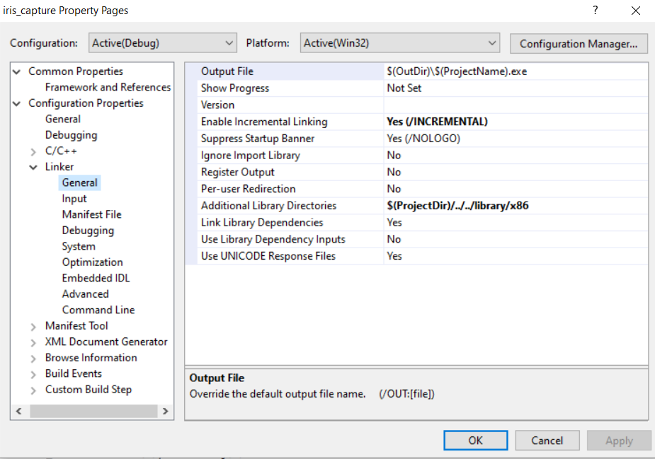

1. Select “Configuration Properties->Linker->Input->Additional Dependencies” and configure libIriEnvoy32.lib or libIriEnvoyMK64.lib as “Additional Dependencies” of target platform Win32 or x64.

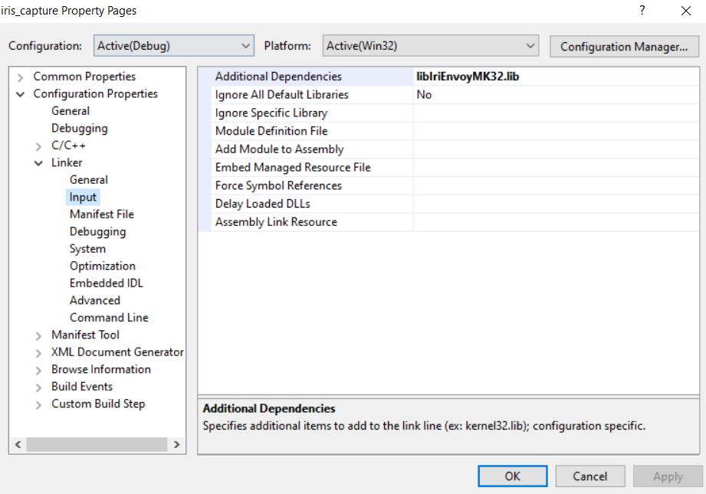

1. Rebuild the project.
2. **Question:**

**How do I confirm that the device is correctly plugged into the computer?**

Answer:

1. Connect your IriEnvoy-MK device to your computer's USB port and supply enough power to the device.
2. Right-click on "My Computer" from your desktop or Windows Explorer, and select "Manage."
3. Select "Device Manager" in the left pane of the Computer Management window.
4. Locate and expand "Cameras" in the right pane.
5. If you see the device’s name, the device has been plugged into the computer correctly and ready for use.

1. **Question:**

**What does the “Device not found” error mean?**

Answer:

The message indicates that the program cannot find any appropriate device in the host system. First of all, users need to check the cables and power supply and make sure the device has been plugged into the host computer properly.

Secondly, IriTech provides its customers with various iris-recognition devices, each of which shares several major functionalities with the others yet carries its own characteristics. The SDKs for different product lines are different from each other.

If a customer has purchased multiple products from IriTech and installed them in the same host system, he/she should pay attention to use the correct SDK to control each product.

# Legal Notice

## Warranty Agreement

|  |  |
| --- | --- |
| IriTech IriCAMM / IriTerminal / IriMobile / IriMagic/ IriEnvoy-MK / IriHerald | |
| Warranty Length | 1 Year Limited: Parts & Labor, Mail in or Carry in |
| Hardware Technical Support | 1 Year |
| Software Support | 90 days |
| Website | http://www.iritech.com |
| Service Phone Number | +1 703 877 2135 (United States)  +82 2 872 3812 (Korea) |

**THIS AGREEMENT CONTAINS A MANDATORY AND BINDING ARBITRATION PROVISION IN WHICH YOU AND IRITECH AGREE TO RESOLVE ANY DISPUTES BETWEEN YOU AND IRITECH BY BINDING ARBITRATION. PLEASE SEE SECTION 10 BELOW.**

This Agreement (“Agreement”) is between the original purchaser (“You”) and IriTech, Inc. (“IRITECH”) and applies to IRITECH products (“Products”) and services purchased by you from IRITECH or affiliates or an IRITECH authorized reseller (“Reseller”). This limited warranty extends only to You, the original purchaser, and is not transferable to anyone who subsequently purchases, leases, or otherwise obtains the Product from You.

The term of this Limited Warranty (the “Limited Warranty Period”) is identified in the reference table included with this Agreement (Warranty Reference Table”). The Limited Warranty Period commences on the date of purchase by You. Your original purchase invoice (sales receipt) showing the date of purchase of the Product is your proof of the date of purchase.

**Product Limited Warranty.** IRITECH warrants that its Products will be free from defects in materials and workmanship for the Limited Warranty Period. During the Limited Warranty Period, IRITECH will, as its option; (i) provide replacement parts necessary to repair the Product; (ii) repair the Product or replace it with a comparable product; or (iii) refund the amount You paid for the Product, LESS DEPRECIATION, upon its return. Replacement parts and Products will be new or serviceably used, comparable in function and performance to the original part or Product and warranted for the remainder of the original warranty period or, if longer, 90 days after they are shipped to you.

**Technical Support.** During the Limited Warranty Period, IRITECH will provide product technical support by e-mail. The scope of technical support consists of helping you diagnose and resolve problems with defects in Products covered by this Agreement, and, for Camera Products, reinstalling the factory-installed operating system and software to restore it to the original factory configuration. IRITECH may provide technical support via on-line and other methods. IRITECH may change the means through which it provides technical support at any time.

THIS LIMITED WARRANTY DOES NOT COVER MISUSE OR MINOR IMPERFECTIONS IN UNITS THAT MEET DESIGN SPECIFICATIONS OR IMPERFECTIONS THAT DO NOT MATERIALLY ALTER FUNCTIONALITY.

**THIS LIMITED WARRANTY DOES NOT COVER AND IRITECH IS NOT RESPONSIBLE FOR:**

• DAMAGES CAUSED BY MISUSE, ABUSE, ACCIDENTS, FIRE, THEFT, DISAPPEARANCE, MISPLACEMENT, POWER SURGES, VIRUSES, RECKLESS, WILLFUL, OR INTENTIONAL CONDUCT.

• DAMAGES CAUSED BY SERVICING NOT AUTHORIZED BY IRITECH.

• DAMAGES CAUSED BY USAGE THAT IS NOT IN ACCORDANCE WITH PRODUCT INSTRUCTIONS.

• DAMAGES CAUSED BY FAILURE TO FOLLOW THE PRODUCT INSTRUCTIONS OR FAILURE TO PERFORM PREVENTIVE MAINTENANCE.

• DAMAGES CAUSED BY THE COMBINATION OF IRITECH PRODUCTS WITH OTHER NON-IRITECH BRANDED PRODUCTS, ACCESSORIES, PARTS OR COMPONENTS.

• SOFTWARE, INCLUDING THE OPERATING SYSTEM AND SOFTWARE ADDED TO YOUR PRODUCT THROUGH OUR FACTORY-INTEGRATION SYSTEM, THIRD-PARTY SOFTWARE, OR THE RELOADING OF SOFTWARE.

• ANY EQUIPMENT OR COMPONENTS THAT WERE NOT INCLUDED IN YOUR PRODUCT AS ORIGINALLY SOLD TO YOU.

• NORMAL WEAR AND TEAR.

• COSMETIC DAMAGE THAT DOES NOT AFFECT FUNCTIONALITY.

• PRODUCTS WHERE THE IRITECH SERIAL NUMBER IS MISSING, ALTERED OR DEFACED.

1. **Instructions for Warranty Service.** For specific instructions on how to obtain warranty service for your product, please refer to the Warranty Reference Table contained in this Agreement and go to: <http://www.iritech.com>.

**To obtain warranty service:**

• You must assist IRITECH in diagnosing issues with your product and follow IRITECH’s warranty processes.

• You must obtain warranty service from IRITECH or an authorized service center specified by IRITECH. IRIECH will not reimburse you for service performed by others.

• You may be required to deliver and retrieve your product to and from IRITECH or an authorized service facility specified by IRITECH at your expense. When sending a product to IRITECH or the authorized service facility specified by IRITECH, you must deliver the product, freight prepaid, in either its original packaging or packaging affording an equal degree of protection. You are responsible for properly packaging your product, paying all shipping costs, loss or damage to the product during shipping, and any other taxes, fees or charges associated with transporting the product to an authorized IRITECH service facility. **YOU ARE RESPONSIBLE FOR ANY DAMAGE TO YOUR IRITECH PRODUCT DURING SHIPMENT TO US.**

• Before providing your product to IRITECH for service, remove any confidential, proprietary or personal information.

• If IRITECH asks you to return defective parts or products, you must do so within 7 days after you receive the replacement parts or products. IRITECH will charge you for replacement parts or products if you fail to do so.

IT IS YOUR RESPONSIBILITY TO BACK UP THE CONTENTS OR DATA RECORDED ON THE DEVICE BEFORE SERVICES ARE PERFORMED AND REMOVE ANY DATA FROM PARTS OR PRODUCTS RETURNED TO IRITECH. It is possible that the contents recorded will be lost or reformatted in the course of service and IRITECH will not be responsible for any damage to or loss of any programs, data, or other information stored on any media or any part of any product serviced. IF DURING THE REPAIR OF THE PRODUCT THE CONTENTS OF THE DEVICE ARE ALTERED, DELETED, OR IN ANY WAY MODIFIED, IRITECH IS NOT RESPONSIBLE FOR ANY LOSS OF YOUR DATA WHATSOEVER. YOUR PRODUCT WILL BE RETURNED TO YOU CONFIGURED AS ORIGINALLY PURCHASED (SUBJECT TO AVAILABILITY OF SOFTWARE).

1. **Implied Warranties. EXCEPT TO THE EXTENT PROHIBITED BY APPLICABLE LAW, ANY IMPLIED WARRANTY OF MERCHANTABILITY OR FITNESS FOR A PARTICULAR PURPOSE IS LIMITED IN DURATION TO THE DURATION OF THIS WARRANTY.**

Commercial Purchasers: IRITECH extends the above limited warranty to purchasers of Products for industrial, commercial and business use upon the same terms and conditions and exclusions applicable to consumer purchasers. **HOWEVER, WITH RESPECT TO COMMERCIAL PURCHASERS, ALL IMPLIED WARRANTIES, INCLUDING THE IMPLIED WARRANTIES OF MERCHANTABILITY AND FITNESS FOR A PARTICULAR PURPOSE, ARE EXCLUDED AND DISCLAIMED.**

1. **Limitation of Liability. IRITECH SHALL NOT BE LIABLE FOR ANY INCIDENTAL OR CONSEQUENTIAL DAMAGES FOR BREACH OF ANY EXPRESS OR IMPLIED WARRANTY.** IRITECH’S AND YOUR MAXIMUM LIABILITY TO THE OTHER IS LIMITED TO PURCHASE PRICE YOU PAID FOR PRODUCTS OR SERVICES PLUS INTEREST ALLOWED BY LAW. NEITHER YOU NOR IRITECH IS LIABLE TO THE OTHER IF YOU OR IT ARE UNABLE TO PERFORM DUE TO EVENTS YOU OR IT ARE NOT ABLE TO CONTROL, SUCH AS ACTS OF GOD OR FOR VIRUSES, PROPERTY DAMAGE, LOSS OF USE, INTERRUPTION OF BUSINESS, LOST PROFITS, LOST DATA OR OTHER CONSEQUENTIAL, PUNITIVE OR SPECIAL DAMAGES, HOWSOEVER CAUSED, WHETHER FOR BREACH OF WARRANTY, CONTRACT, TORT (INCLUDING NEGLIGENCE), STRICT LIABILITY OR OTHERWISE.

Some states or jurisdictions do not allow the exclusion or limitation of incidental or consequential damages, or allow limitations on how long an implied warranty lasts, so the above limitations may not apply to you. This Limited Warranty gives you specific legal rights and you may have other rights which vary from state to state or jurisdiction to jurisdiction.

1. **Binding Arbitration.** THIS AGREENET PROVIDES THAT ALL DISPUTES BETWEEN YOU AND IRITECH WILL BE RESOLVED BY MANDATORY AND BINDING ARBITRATION TO THE FULLEST EXTENT PROVIDED BY LAW. YOU THUS GIVE UP YOUR RIGHT TO GO TO COURT TO ASSERT OR DEFEND YOUR RIGHTS UNDER THIS AGREEMENT (EXCEPT FOR MATTERS THA MAY BE TAKEN TO SMALL CLAIMS COURT AS FURTHER SET FORTH BELOW IN THIS SECTION 7).

To the fullest extent provided by law, and except as otherwise provided below, You and IRITECH agree that any Dispute between You and IRITECH will be resolved exclusively and finally by binding arbitration administered by the American Arbitration Association (AAA) and conducted in accordance with AAA’s Supplementary Procedures for Consumer-Related Disputes of the Commercial Arbitration rules and the Consumer Due Process Protocol. YOUR RIGHTS WILL THEREFORE BE DETERMINED BY A NEUTRAL ARBITRATOR AND NOT A JUDGE OR JURY. You and IRITECH will agree on another arbitration forum if AAA ceases operations.

The arbitration will be conducted before a single arbitrator, and will be limited solely to the Dispute between You and IRITECH. Arbitration is a process whereby a dispute is submitted to an arbitrator, for a final and binding determination, known as the award. The arbitrator is an individual, similar to a judge, who reviews and weighs evidence provided by both parties, and renders an award enforceable in court. Arbitrator decisions are as enforceable as any court order and are subject to VERY LIMITED REVIEW BY A COURT. YOU ACKNOWLEDGE THAT, BY WAY OF THIS AGREEMENT, YOU AND IRITECH WAIVE ALL RIGHTS TO A JURY TRIAL.

The arbitration, or any portion of it, will not be consolidated with any other arbitration and will not be conducted on a class-wide or class action basis. The arbitration shall be held at any reasonable location near your residence by submission of documents, by telephone, online or in person whichever method of presentation You choose. Under the AAA Supplementary Procedures for Consumer-Related Disputes and Consumer Due Process Protocol, You retain the right to seek relief in a small claims court for Disputes within the scope of the small claims court’s jurisdiction. If you prevail in the arbitration of any Dispute with IRITECH, IRITECH will reimburse You for any fees You paid to AAA in connection with the arbitration.

Any decision rendered in such arbitration proceedings will be final and binding on the parties, and judgment may be entered thereon in any court of competent jurisdiction.

Should either party bring a Dispute in a forum other than AAA, the arbitrator may award the other party its reasonable costs and expenses, including legal fees, incurred in staying or dismissing such other proceedings or in otherwise enforcing compliance with this dispute resolution provision. **You understand that, in the absence of this provision, you would have had a right to litigate disputes through a court**, including the right, if any and subject to the rules of your jurisdiction, to litigate claims on a class-wide or class-action basis, **and that you have expressly and knowingly waived those rights and agreed to resolve any Disputes through binding arbitration in accordance with the provisions of this paragraph.**

This arbitration provision shall be governed by the Federal Arbitration Act, 9 U.S.C. Section 1, *et seq*. For the purposes of this provision, the term “Dispute” means any dispute, controversy, or claim arising out of or relating to (i) this Agreement, its interpretation, or the breach, termination, applicability or validity thereof, (ii) the related order for, purchase, delivery, receipt or use of any product or service from IRITECH, or (iii) any other dispute arising out of or relating to the relationship between you and IRITECH; the term “IRITECH” means IRITECH, Inc, its parents, subsidiaries, affiliates, directors, officers, employees, beneficiaries, agents, assigns, component suppliers (both hardware and software), and/ or any third party who provides products or services purchased from or distributed by IRITECH; and the term “You” means the original purchaser and those in privacy with the original purchaser, such as family members or beneficiaries. Information may be obtained from the AAA on line at www.adr.org, by calling 800-778-7879 or writing to American Arbitration Association, 1633 Broadway, 10th Floor, New York, NY, 10019.

1. **General.** IRITECH may assign this Agreement and/or any associated service plan without your consent and without notice to You. If IRITECH does assign this Agreement and/or any associated service plan, the assignee will assume all obligations to You, IRITECH will be released of all obligations, and You agree to look solely to the assignee for the performance of all obligations under this Agreement and/or any associated service plan. IRITECH, Inc. and its subsidiaries and affiliates are intended beneficiaries of this Agreement. If there is any inconsistency between this Agreement and any other agreement included with or relating to products or services purchased from IRITECH, this Agreement shall govern. This Agreement may not be modified, altered or amended without the written agreement of IRITECH. Any additional or altered terms shall be null and void, unless expressly agreed to in writing by IRITECH. If any term of this Agreement is illegal or unenforceable, the legality and enforceability of the remaining provisions shall not be affected or impaired. This Agreement shall be interpreted under the laws of the State of South Dakota, without giving effect to conflicts of law rules.
2. **Privacy Notice.** You can review IRITECH’s Privacy Policy on our web site, located at [www.iritech.com](http://www.iritech.com). IRITECH will maintain and use your customer information in accordance with its Privacy Policy.
3. **For Residents of Canada:** This Agreement is subject to the applicable provisions of Canadian consumer protection laws that cannot be derogated from by private agreement.
4. **International Support:** You must comply with all applicable export laws and regulations if you export the product from Korea, the United States or Canada. IRITECH does not accept for return any products purchased from a reseller. Customers may be responsible for paying all freight charges incurred in shipping, importing/exporting and receiving replacement products and parts and for arranging and paying for the shipment of any defective part(s) back to the IRITECH.

All international customers are responsible for all customs duties, VAT and other associated taxes and charges.

Please send correspondence about this Agreement to:

**IRITECH Customer Service Department**

**Attn: Warranty Services**

**3951 Pender Dr., Suite 120A**

**Fairfax, VA 22030**

**Or**

**A-801, Daesung D-POLIS Knowledge Industry Center,**

**606, Sobusatgil, Gasan-dong, Geumchun-gu, Seoul, South Korea**

Current information on technical support and warranty policies, phone numbers and other service information is available on our web sites: [www.iritech.com](http://www.iritech.com)

## End-User License Agreement

IMPORTANT-READ CAREFULLY:

THIS IS A LEGAL AGREEMENT BETWEEN YOU (EITHER AN INDIVIDUAL OR A SINGLE ENTITY) AND IRITECH, INC. (“IRITECH”) STATING THE TERMS THAT GOVERN YOUR USE OF THIS SOFTWARE SERVICE. THIS AGREEMENT - TOGETHER WITH ALL UPDATES, ADDITIONAL TERMS, SOFTWARE LICENSES, AND ALL OF IRITECH, INC.’S RULES AND POLICIES-COLLECTIVELY CONSTITUTES THE "AGREEMENT" BETWEEN YOU AND IRITECH, INC.

IF YOU DO NOT AGREE TO THESE TERMS AND CONDITIONS, DO NOT OPEN THE PACKAGE AND DO NOT INSTALL, COPY OR USE THE SOFTWARE; YOU MAY RETURN IT TO YOUR PLACE OF PURCHASE WITHIN FOURTEEN (14) DAYS OF PURCHASE FOR A REFUND OF ITS PURCHASE PRICE. IF THE PACKAGE HAS BEEN OPENED OR THIS SOFTWARE HAS BEEN USED WITHOUT OPENING OF THE PACKAGE, YOU SHALL BE DEEMED TO ACCEPT AND AGREE TO THESE TERMS AS PRESENTED TO YOU HEREINAFTER.

Definitions

The following terms used in this Agreement, to all intents and purposes of this Agreement, have the meaning as specified below respectively except where the context requires otherwise:

1. “Products” means hardware products such as including, but not limited to, IriCAMM products, IriTerminal products, IriMobile products, IriMagic products, IriEnvoy-MK products, IriHerald products, any and all iris-recognition cameras that are developed and/or manufactured by IRITECH.
2. “Embedded Software” means any and all software embedded, recorded, contained or enclosed in hardware products and any related printed or electronic material developed and/or provided by IRTECH, and any updates, modifications, revisions, copies, documentation and design data of the foregoing.
3. “Supporting Software” means any and all software recorded, contained or enclosed in media products and any related printed or electronic material developed and/or provided by IRTECH, and any updates, modifications, revisions, copies, documentation and design data of the foregoing. Supporting Software specifically excludes Embedded Software.
4. “Software” means any and all of Embedded Software and/or Supporting Software.
5. “License Tool” means a file or hardware device provided by IRITECH to you so that it may be used to activate the Software.
6. “Computer” means the computer, server, workstation, embedded system, or any device on which any software can be used.

Any terms used in this Agreement in the singular form includes the meaning of plural and vice versa, if the context requires.

OWNERSHIP, COPYRIGHT, AND INTELLECTUAL PROPERTY RIGHTS.

Although you own the hardware and/or physical media in which the Software is embedded, recorded, contained or enclosed, the Embedded Software and/or Supporting Software is the property of IRITECH.

Title to and intellectual property rights of (including copyrights to) the Embedded Software and Supporting Software, in whole and in part, and all copies thereof, and all modifications, enhancements, and other alterations (“Modifications) and derivatives of the Embedded Software and Supporting Software, if any, are, and shall remain, the sole and exclusive property of IRITECH regardless of who made such modifications or derivatives.

GRANT OF LICENSES.

IRITECH grants you a license authorizing the use of the Software provided that you comply with all terms and conditions of this EULA.

Nothing contained herein shall be construed as transferring any technology including patent, utility model, trademark, design, copyright or trade secrets on or relation to the Embedded Software and Supporting Software.

You may not use the Embedded Software and/or Supporting Software (i) to build any product or software that competes with Products, Embedded Software, and/or Supporting Software; or (ii) to help or assist a person, natural or legal, who directly or indirectly competes with IRITECH or its business or products. You may not use the Products and/or Software for any illegal purpose.

RESTRICTIONS ON USE OF SOFTWARE.

IRITECH licenses the Embedded Software on a per-Product basis. You may not copy the Embedded Software for any purpose.

IRITECH licenses only one copy of the Supporting Software for each Product purchased. You may install and use only one copy of Supporting Software on one Computer for each Product purchased. You may not copy the Supporting Software for any purpose.

In case there is a license activation mechanism required by IRITECH, the Supporting Software must be activated in accordance with the procedure of the License Tool provided by IRITECH.

You may not, and you will not encourage, assist or authorize any other person to modify, reverse assemble, decompile, reverse compile, or otherwise reverse engineer the Product or the Software, or attempt to discover in any way the underlying code of, the Software, whether in whole or in part, create any derivative works from or of the Software, or bypass, modify, defeat or tamper with or circumvent any of the functions or the licensing and/or Software protection mechanism of the Products.

*SOFTWARE TRANSFER.*

**Internal.** You may move the Software to a different Computer. After the transfer, you must completely remove the Software from the former Computer.

**Transfer to Third Party.** The initial user of the Software may make a one-time permanent transfer of this EULA and Software to another end user, provided the initial user retains no copies of the Software. The transfer may not be an indirect transfer such as a consignment. Prior to the transfer, the end user receiving the Software must agree to all the EULA terms.

TERMINATION.

Without prejudice to any other rights, IRITECH may terminate this EULA if you fail to comply with the terms and conditions of this EULA. In such event, you must destroy all copies of the Software and all of its component parts.

LIMITED WARRANTY.

IRITECH warrants that any Product provided will be free from defects in material and workmanship for a period of twelve (12) months from the date of initial purchase from IRITECH, or its distributors.

THE SOFTWARE AND DOCUMENTATION IS PROVIDED “AS IS” AND WITHOUT WARRANTY OF ANY KIND, EITHER EXPRESS OR IMPLIED, INCLUDING, BUT NOT LIMITED TO, THE IMPLIED WARRANTIES OF MERCHANTABILITY, FITNESS FOR A PARTICULAR PURPOSE, AND NONINFRINGEMENT OF INTELLECTUAL PROPERTY. IRITECH DOES NOT WARRANT THAT SOFTWARE WILL MEET YOUR REQUIREMENTS OR THAT OPERATION OF SOFTWARE WILL BE UNINTERRUPTED OR ERROR FREE. IRITECH MAKES NO WARRANTIES WITH RESPECT TO SERVICES.

IN ANY CASE, IRITECH’S ENTIRE LIABILITY AND YOUR EXCLUSIVE REMEDY SHALL BE, AT IRITECH’S SOLE OPTION, EITHER:

(1) REPAIR OR REPLACEMENT, OR;

(2) REFUND OF THE PRICE PAID UPON RETURN OF SOFTWARE TO IRITECH

For the Products repaired, rectified or replaced under this Agreement shall be warranted for the balance of the original Products warranty.

LIMITATION OF LIABILITY.

EXCEPT WHERE THIS EXCLUSION OR RESTRICTION OF LIABILITY WOULD BE VOID OR INEFFECTIVE UNDER APPLICABLE STATUTE OR REGULATION, IN NO EVENT SHALL IRITECH BE LIABLE FOR INDIRECT, SPECIAL, INCIDENTAL, OR CONSEQUENTIAL DAMAGES (INCLUDING LOST PROFITS OR SAVINGS) WHETHER BASED ON CONTRACT, TORT OR ANY OTHER LEGAL THEORY, EVEN IF IRITECH HAS BEEN ADVISED OF THE POSSIBILITY OF SUCH DAMAGES.

ALL THE LIABILITIES ARISING OR ALLEGED IN CONNECTION WITH THE USE OF SOFTWARE SHALL NOT EXCEED THE PRICE OF RELEVANT PRODUCTS PAID BY YOU, UPON WHICH SUCH LIABILITIES ARE BASED. IF SUCH LIABILITY RELATES TO PARTICULAR ITEMS OF PRODUCTS, SOFTWARE OR SERVICES PROVIDED BY IRITECH, SUCH LIABILITY SHALL BE LIMITED TO THE PRICES OR FEES PAID FOR THE RELEVANT PRODUCTS, SOFTWARE OR SERVICES.

IN THE CASE WHERE NO AMOUNT WAS PAID, IRITECH SHALL HAVE NO LIABILITY FOR ANY DAMAGES WHATSOEVER.

THE PROVISIONS OF THIS SECTION SHALL SURVIVE TERMINATION, EXPIRATION OR CANCELLATION OF THE LICENSE AND/OR THE AGREEMENT.

Governing Law and Jurisdiction.

This Agreement shall be executed in English text as the controlling text and governed by and construed in accordance with the laws of the Commonwealth of Virginia. Any dispute, controversy or difference which may arise between the parties hereto out of or in relation to or in connection with this Agreement, Products or Software, shall be settled amicably through negotiations between the parties. If such negotiations should fail, then such disputes, controversies or differences shall be submitted to a court that has jurisdiction over the place where IRITECH has the relevant office.

ENTIRE AGREEMENT AND SEVERABILITY.

This EULA (including any addendum or amendment to this EULA which is included with the Software) is the entire agreement between you and IRITECH relating to the Software and the support services (if any) and they supersede all prior or contemporaneous oral or written communications, proposals and representations with respect to the Software or any other subject matter covered by this EULA. To the extent the terms of any IRITECH policies or programs for support services conflict with the terms of this EULA, the terms of this EULA shall control. If any provision of this EULA is held to be void, invalid, unenforceable or illegal, the other provisions shall continue in full force and effect.

**- The end of the document -**